Four Channel PMT Controller Circuit Specification

TABLE OF CONTENTS

1.0 CIRCUIT OVERVIEW 2
2.0 CIRCUIT DETAILS 2
2.1 PMT Module 3
2.1.1 PMT Error Detection 4
2.2 Amp/Mixer Connections 4
2.3 Handunit Connections 4
3.0 COMMAND SET 5
3.1 High Voltage Commands 5
3.2 Black Level Commands 6
3.3 Mixer Command 6
3.4 Gain Command 6
3.5 Query Command 6
3.5.1 High Voltage [0-15] 6
3.5.2 Black Level [16-31] 7
3.5.3 Mixer [32-33] 7
3.5.4 Gain [34-37] 7
3.5.5 PMT Code [38-41] 7
3.5.6 PMT Error Counter [42-53] 7
4.0 PIC18F4455 PORT USAGE 8

TABLES

Table 1. PMT module identification codes. 3
Table 2. PMT module connector pinouts. 3
Table 3. General purpose IO pin usage as a function of PMT module. 3
Table 4. Amplifier connector 4
Table 5. Handunit connector pinouts. 5
Table 6. ASCII Command Set 5

FIGURES

Figure 1. Current PCB Layout 2
Figure 2. Contents of Status Array 6

CIRCUIT OVERVIEW

The four channel PMT controller board is a PIC microcontroller based device that communicates with a PC by USB as an HID device and with a PIC-based “handunit” via PIC-to-PIC RS-232 protocol. These two external inputs (USB and RS-232) send strings to the PMT controller that:
1. Sets the four high voltage levels of the PMTs.
2. Provide four bipolar offset voltages for blacklevel adjustment on an external amplifer system.
3. Control a 2 level programmable gain of a four channel external amplifier system.
4. Control analog mixing of channels of the four channel external amplifier system.
5. Identifies which type of PMT module is attached to the controller.
6. Depending on the type of PMT module attached, communicate with it (see Table 3).
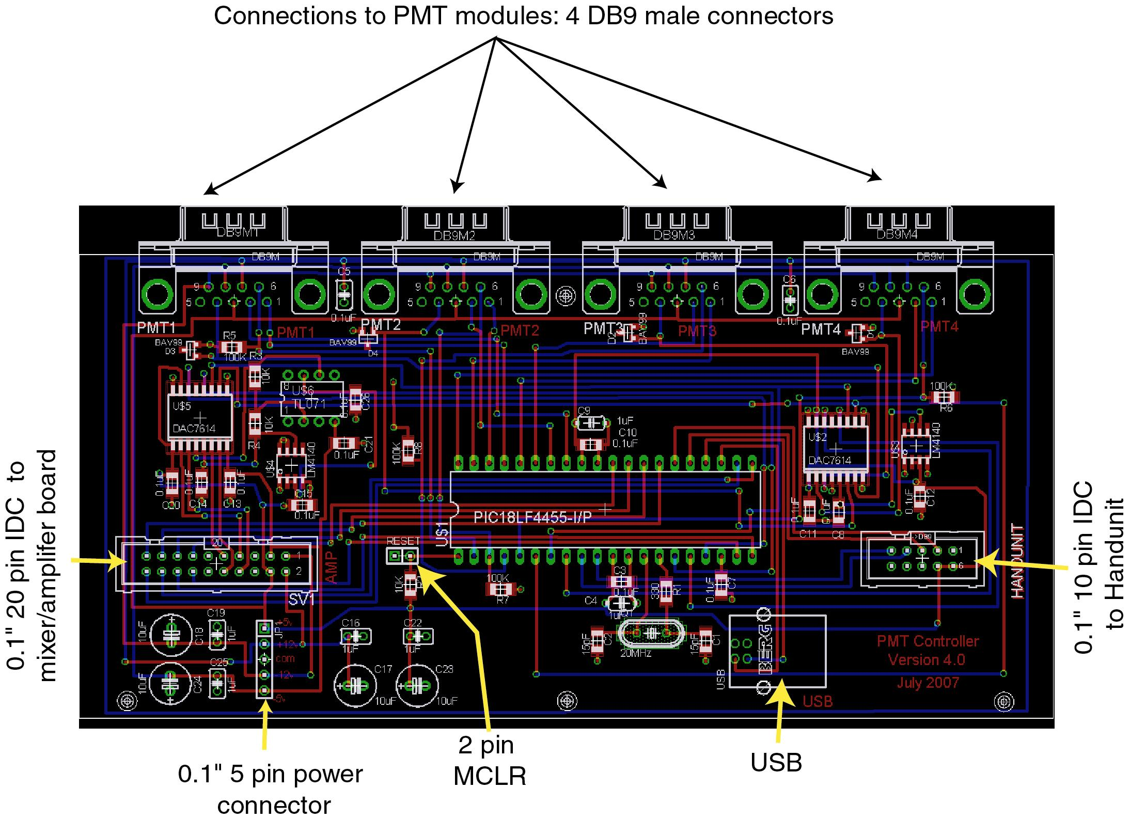
Figure 1. Current PCB Layout

CIRCUIT DETAILS

The circuit employs a PIC18F4455 USB enabled microcontroller to program two 4 channel TI DAC7614 digital-to-analog converters via an SPI interface. These provide the control voltages for the PMT high voltage and a bipolar offset voltage for the blacklevels on each channel of acquisition.

PMT Module

ADC inputs on the PIC (AN0-AN3) are used to monitor an input pin from each PMT module that tells the controller board which type of PMT is attached to each of the four ports. The software should expect to find one of six possible analog voltage levels a PMT ID port:

PMT code | PMT module | Voltage code | Acceptable range
0 | no PMT connected | 0.0V | 0 to 0.50V
1 | HC125 Bialkali PMT module | 1.0V | 0.75 to 1.25V
2 | Ultra Bialkali (UBA) module | 2.0V | 1.75 to 2.25V
3 | H7422P-40MOD type 1 (with cooler and protection circuit) | 3.0V | 2.75 to 3.25V
4 | H7422P-40MOD type 2 (without cooler & protection circuit) | 4.0V | 3.75 to 4.25V
5 | GaAsP hybrid detector (future) | 5.0V | 4.75 to 5.0V
9 | Error. Voltage outside of specified ranges | - | -
Table 1. PMT module identification codes.

Each PMT module has a DB9 male connector on it that is connected to the controller board by a DB9 F-F cable. The pinouts are:

Pin | Function | Pin | Function
1 | GPIO or ADC–use depends on PMT module. | 6 | PMT ID signal (table 1)
2 | GPIO– use depends on PMT module | 7 | +12V
3 | +5V | 8 | -5V
4 | HV control voltage – range depends on PMT module | 9 | -12V
5 | Common (0V)
Table 2. PMT module connector pinouts.

The use of the GPIO lines depends on the module attached as follows:

PMT module | Pin 1 Function | Pin 2 Function
Type 1: HC125 | Not used | Not used
Type 2:  UBA | Not used | Not used
Type 3:  H7422-1 | TTL output – resets the H7422P module if protection circuitry is triggered. | TTL Input – monitors the shutoff circuitry.
Type 4:  H7422-2 | Analog input – monitors the averaged PMT output | Not used.
Type 5:  Hybrid | Not yet defined | Not yet defined
Table 3. General purpose IO pin usage as a function of PMT module.

PMT Error Detection

Type 3 PMTs (Hamamatsu H7422 Series) are protected by a M9012 Temperature Control and Power Supply Unit. When the overload protective function of the H7422 is triggered, this unit asserts a TTL output called PMT-ERR-TTL which is pin 9 of connector “CN05” on the M9012 unit. This signal is connected to Pin 2 of the PMT module on all four channels as a TTL input. The error signal is only monitored when the controller detects a PMT of type 3 on that channel.

When the controller detects an error, it asserts a TTL output called PMT-POW-TTL which resets the PMT by turning the PMT high voltage back on. This signal is connected from Pin 1 of the PMT module to pin 7 of connector “CN05” on the M9012 unit.

If the error condition still exists (i.e. the PMT is still overloaded), the error signal will continue to be re-asserted until the error condition is corrected or the PMT power is turned off. Each channel has an error counter which increments every time a PMT overload error is detected. The counter values are stored in the Status array which is periodically read by the PC (See section 3.5).

Amp/Mixer Connections

Connection to the four channel amplifier/mixer board is through the 20 pin IDC connector (0.100” spacing). This connection will also be used later with our next generation of acquisition hardware, but for now Table 3 refers to how the GPIO will be used with the current Amp/Mixer board design:

Pin | Function | Pin | Function
1 | -12V | 11 | Common (0V)
2 | +12V | 12 | Common (0V)
3 | -5V | 13 | GPIO (RD7)
4 | +5V | 14 | GPIO (RD0) – mixer 1
5 | Common (0V) | 15 | GPIO (RD6)
6 | Common (0V) | 16 | GPIO (RD1) – mixer 2
7 | Channel 4 blacklevel | 17 | GPIO (RD5) – gain 4
8 | Channel 3 blacklevel | 18 | GPIO (RD2) – gain 1
9 | Channel 2 blacklevel | 19 | GPIO (RD4) - gain 3
10 | Channel 1 blacklevel | 20 | GPIO (RD3) – gain 2

Table 4. Amplifier connector

Handunit Connections

In addition to PC control, a handunit may be used to control PMT high voltage values, blacklevel settings, channel mixing, and amplifier gain. The handunit communicates with the controller via RS-232 protocol using the command set described below in section 3.0. The connection to the controller handunit is through a 10 pin IDC connector that connects to a DB9 connector in the case (a preassembled cable). The device and package used in the Eagle file is a custom 10 pin IDC connector layout from wz.lbr library file and the pin numbering reflects the DB9 pins, rather than the standard IDC numbering pattern. The pinouts are:

Pin | Function | Pin | Function
1 | Common (0V) | 6 | +5V
2 | RX - PIC pin RC7 | 7 | +5V
3 | TX - PIC pin RC6 | 8 | Common (0V)
4 | GPIO - PIC pin RE1 | 9 | Common (0V)
5 | GPIO - PIC pin RE2

Table 5. Handunit connector pinouts.

COMMAND SET

Commands which control the functions of the board will be passed between the user interface and the board as ASCII characters. After any command is received, the 54-byte Status array will be returned to the PC. The Status array is described in section 3.5.

Command | Function | Usage example
Hn#### | Sets the PMT n HV to the value specified by XXXX (4 digit integer max.) See section 3.1. | “H1800#” – sets PMT 1 HV to 800 volts. See section
Bns### | Sets the black level of channel n to s###, where s is the sign and ### is a value from 0 to 100. This value is the percentage of full scale voltage output from the blacklevel DAC where 100% is 2.5V. See section 3.2. | “B3-50#” sets the black level of channel 3 to -50% which corresponds to changing the DAC to -1.25V.
Mn# | Sets mixer n. # is either 0 (set pin LO) for unmixed or 1 (set pin HI) for channel mixing.  See section 3.3. | “M11” – sets mixer 1 high so that channel 1 output is the sum of input 1 and 2.
Gn# | Sets channel n amplifier gain HI or LO.  See section 3.4. | “G20”– sets channel 2 gain LO
? | Queries status of all PMT Controller settings.  See section 3.5. | “?” Returns 54-byte Status array.

Table 6. ASCII Command Set

High Voltage Commands

The voltage value (the last four characters of the command) corresponds to the high voltage setting used by the PMT. The actual voltage output by the High Voltage DAC is the voltage value divided by 1000. The pound sign (ASCII 0x23) is used as a place-holder when the voltage value is less than 4 digits. The DAC7614 uses addresses 0-3 to access its four channels. The software is designed so that the user will access each channel using addresses 1-4 so that the numbering of DAC channels and the numbering of PMT channels will be consistent. Using the example command “H1800#” from Table 6 above, the High Voltage DAC output associated with the PMT on channel 1 is set to 0.8V. The values sent to the High Voltage DACs are limited by software. PMT types 1 and 2 are limited to a maximum of 1.2V. PMT types 3 and 4 are limited to a maximum of 0.9V.

Black Level Commands

The voltage value (the last three characters of the command) corresponds to the percentage of full scale voltage output from the Black Level DAC. The full scale voltage is 2.5V, so a voltage value of +100 will output 2.5V, and a value of -100 will output -2.5V. The pound sign (ASCII 0x23) is used as a place-holder when the voltage value is less than 3 digits.
.

Mixer Command

There are two mixer channels which control analog mixing of the four channel external amplifier system. Setting mixer 1 high sets the output of channel 1 to be the sum of inputs 1 and 2. Setting mixer 2 high sets the output of channel 2 to be the sum of inputs 3 and 4.

Gain Command

The gain command controls a 2-level programmable gain of a four channel external amplifier system. Gain channels 1-4 can be set either high (1) or low (0).

Query Command

The query command “?” will be sent from the PC approximately once every second when no other tasks are being performed. The controller returns a 54-byte array which contains the status of all of the PMT controller settings (in ASCII). The Status array will also be sent to the PC in response to any other command. below shows the contents of the Status array, and the following sections describe the details of each element.

0
1
2
3
4
51
5222
53
48
4922
50
5
6
7
8
9
10
11
12
13
14
15
16
17
18
19
20
21
22
23
24
25
26
27
28
29
30
31
32
33
34
35
36
37
38
39
40
41
42
43
44
45
46
47
HV-PMT1
HV-PMT2
HV-PMT3
HV-PMT4
BL-PMT1
BL-PMT2
BL-PMT3
BL-PMT4
M1
M2
G1
G2
G3
G4
PMT1
PMT2
PMT3
PMT4
ERR
PMT1
ERR
PMT2
ERR
PMT3
ERR
PMT4
Status[54]

Figure 2. Contents of Status Array

High Voltage [0-15]

The PMT high voltage settings for all four channels are stored in bytes 0-15. Each byte holds one digit, and the value for each PMT channel is four digits long. If a channel has a high voltage setting that is less than four digits, the pound sign (#) is used as a place holder. For example, a high voltage of 1200 on channel 1 would be stored in the HV-PMT1 section (bytes 0-3) as “1200” while a high voltage of 800 would be stored as “800#”. Each high voltage setting section of the Status array will hold the last HV command received by the controller. If no high voltage commands have been received on any channel, that section will contain zeros.

Black Level [16-31]

The PMT black level settings for all four channels are stored in bytes 16-31. Each byte holds one digit, and the value for each PMT channel is four digits long. The register will hold the last black level command received by the controller. The first digit is used for the sign (+ or -), and the last three digits hold the black level setting (as a percentage and not the actual voltage). If a black level setting is less than three digits, a pound sign (#) will be used as a place holder. For example, if the black level of channel 3 is set to -50%, the BL-PMT3 section of the Status array (bytes 24-27) will contain “-50#”. If no black level commands have been received on any channel, that section will contain zeros.

Mixer [32-33]

The Mixer1 setting is stored in byte 32, and the Mixer2 setting is stored in byte 33. Each element will contain the last setting received by the controller which can either by high (1) or low (0). If a mixer command has not yet been received by the controller, that element will contain a 0.

Gain [34-37]

The settings for the four Gain channels are stored in bytes 34-37. Each element will contain the last setting received by the controller which can either by high (1) or low (0). If a gain command has not yet been received by the controller, that element will contain a 0.

PMT Code [38-41]

Bytes 38-41 hold the PMT codes for each of the four channels. The code is one digit which describes the type of PMT connected to that channel. The valid code values and what they represent can be found in Table 1 above.

PMT Error Counter [42-53]

Bytes 42-53 hold the PMT Error Counters as described in section above. The counter for each PMT channel is three digits long. If the count is less than three digits, the empty places will contain zeros. For example, if the controller has detected 7 errors on channel 1, section “ERR PMT1” of Status (bytes 42-44) will contain “007”. The counters roll over after 255.

PIC18F4455 PORT USAGE

- PMT ID lines - use as analog inputs. ID codes in Table 1.
RA0 (AN0) = PMT 1
RA1 (AN1) = PMT 2
RA2 (AN2) = PMT 3
RA3 (AN3) = PMT 4

- PMT communication lines. See Table 3:
RB0/AN12 – PMT module GPIO or ADC
RB1/AN12 – PMT module GPIO or ADC
RB2/AN12 – PMT module GPIO or ADC
RB3/AN12 – PMT module GPIO or ADC
RB4 – PMT module GPIO
RB5 – PMT module GPIO
RB6 – PMT module GPIO
RB7 – PMT module GPIO

- DAC control
RA4 = SDI (output)
RA5 = CLK (output)
RC0 = Chip Select for blacklevel DAC (CS_BL)
RC1 = Chip Select for high voltage DAC (CS_HV)
RC2 = DAC Load for blacklevel (LD_BL)
RE0 = DAC Load for high voltage (LD_HV)

- Amp/mixer connections:
RD0 = Mixer 1 (HI adds channels 1 and 2)
RD1 = Mixer 2 (HI adds channels 3 and 4)
RD2 = Gain 1 (HI = high gain, LO = low gain)
RD3 = Gain 2 (HI = high gain, LO = low gain)
RD4 = Gain 3 (HI = high gain, LO = low gain)
RD5 = Gain 4 (HI = high gain, LO = low gain)
RD6 = future use
RD7 = future use

- Handunit connections:
RC6 = TX line (RS-232)
RC7 = RX line (RS-232)
RE1 = future use
RE2 = future use

- MCLR
RE3 = Reset switch

